Patient Name | MANAKKA DEVI | Patient ID | 4804
Age/D.O.B | 65Y | Gender | F
Ref Doctor | DR CHANDRAKANT, MS (ORTHO) | Date | 15 May 24
MRI Spine Dorsal Plain and Contrast
History
Back pain and both lower limbs weakness x 3 months and fever
Technique
T1W, T2W Sagittal
T2W irm Coronal
T1W, T2W axial
POST CONTRAST
Observations
Multiple altered signal intensity lesions noted involving D1, D7,D8 ,D9, D11,D12 vertebrae hypointense on T1, hyperintense on T2 and STIR also involving few of the posterior elements.
Severe wedge compression with collapse is noted of D10 vertebral body with retropulsion of the posterior cortex causing compression on the lower cord (cord measurement 5.86mm) . The lesion shows heterogeneous enhancement on post-contrast.
The ligamentum flavum thickness is within normal limits.
The paraspinal soft tissues appear normal.
Multiple enlarged discrete bilateral supraclavicular or infraclavicular axillary nodes are noted of varying sizes.
Liver shows enlargement with multiple heterogeneous signal intensity lesions noted in both lobes likely represent neoplastic aetiology
Incidental note is made of multiple enlarged bilateral para-aortic nodes seen
Multifocal areas of altered signal intensity is also noted involving visualised upper lumbar vertebrae- likely neoplastic aetiology
Impression
- Multiple altered signal intensity lesions noted involving D1, D7,D8, D9, D11-D12 vertebrae hypointense on T1, hyperintense on T2 and STIR also involving few of the posterior elements.
- Severe wedge compression with collapse noted of D10 vertebral body with retropulsion of the posterior cortex causing compression on the lower cord. The lesion shows heterogeneous enhancement on post-contrast.
- Findings likely representative of neoplastic aetiology possibly metastatic
Recommended clinical lab parameter and tissue sampling correlation
Key Images
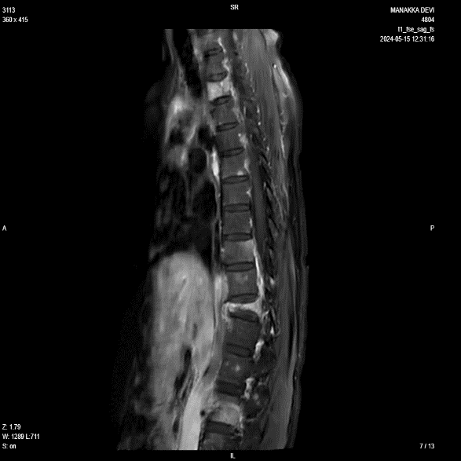
Image 1
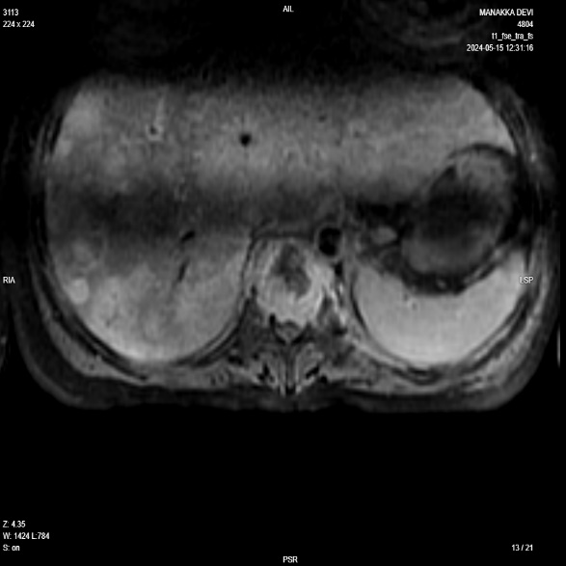
Image 2
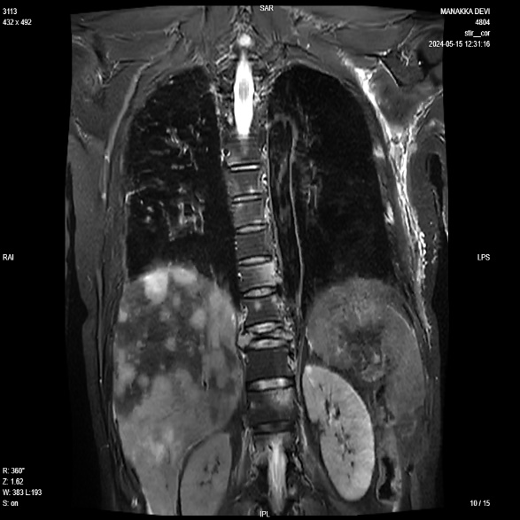
Image 3
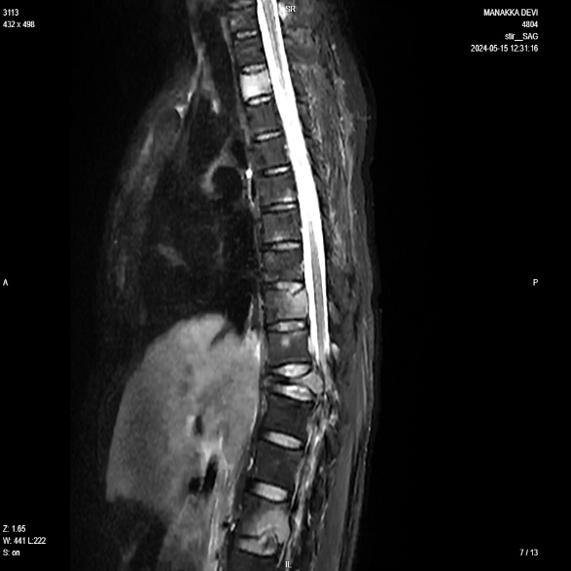
Image 4

